Please use the pregnancy test provided and complete the symptom checklist on the date and as directed below.
Date of Step 1 (Mifepristone): ______________
Date of pregnancy test and symptom checklist (14-21days post step 1): _____________
Pregnancy test instructions
If your pregnancy test is positive or inconclusive please contact the practice on <practice number> and ask to speak with a nurse.
Check4® is a urine pregnancy test to use check the MS2Step has been effective.
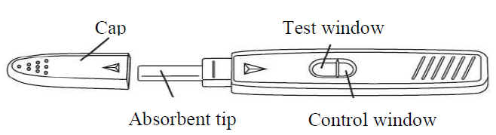

Please complete this test 14-21 days (usually 19 days) after Step1 of your medication. The date for you to compete this test will be written on the box. Using the pregnancy test earlier than 14 days will result in the test not being able to be interpreted.
INSTRUCTIONS
Two options to use the pregnancy test:
- Remove the pregnancy test from the foil pouch and remove the cap.

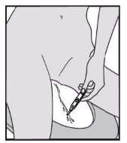
  - Option 1
Hold the absorbent tip directly in your urine stream for 5-10 seconds. Take care that no urine enters the testing window.
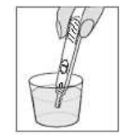
  - Option 2
Collect your urine in a clean and dry container and dip the absorbent tip into the urine for at least 5-10 seconds in order for it to be completely soaked.

- Replace the cap on the pregnancy test
- Lay the test device on a dry flat surface with the two windows facing up. Results will be shown in the windows and can be read between 5-10mins. Do not read test after 10mins.
Results:
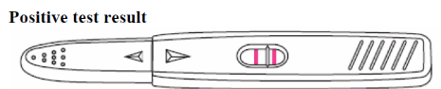
Positive result: two lines appear on the pregnancy test. One line in the control window and 1 line in the test window.
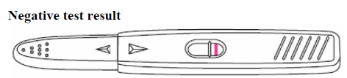
Negative result: one line appears in the control window.
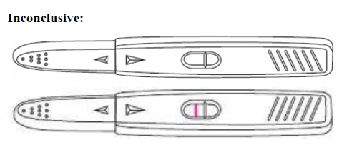
Inconclusive result: no lines appear or one line appears in the test window ONLY.

Urine pregnancy test result:
Positive: Negative: Inconclusive:

Warning
The Check4® urine pregnancy test is only used to check that the MS2Step has been effective. It is not to be used for future pregnancies.
If you do not use the Check4® urine pregnancy test, please dispose of it appropriately.

Symptom checklist
Please complete this symptom checklist on the same day you use the pregnancy test. If you answer yes to any of the symptoms below contact the practice on <practice number> and ask to speak with a nurse.
Symptom | Yes | No
Bleeding was less than a normal period for me
Pregnancy symptoms are still present, such as tender breasts or feeling sick (nausea) or abdomen (tummy) growing
Persistent bleeding heavier than a period
Strong abdominal (tummy) pain
Fever
Feeling generally unwell or feeling tired

Please complete this symptom checklist 6 weeks after your treatment. If you answer yes contact the practice on <practice number> and ask to speak with a nurse.
Symptom | Yes | No
My period has not returned within 6 weeks of treatment

